UNITED STATES
SECURITIES AND EXCHANGE COMMISSION
Washington, D.C. 20549
SCHEDULE 14A
Proxy Statement Pursuant to Section 14(a) of the
Securities Exchange Act of 1934
(Amendment No.)
Filed by the Registrant ☒
Filed by a Party other than the Registrant ☐
Check the appropriate box:
☐ Preliminary Proxy Statement
☐ Confidential, for Use of the Commission Only (as permitted by Rule 14a-6(e)(2))
☐ Definitive Proxy Statement
☒ Definitive Additional Materials
☐ Soliciting Material Pursuant to §240.14a-12
APELLIS PHARMACEUTICALS, INC.
(Exact name of registrant as specified in its charter)
(Name of person(s) filing proxy statement, if other than the registrant)
Payment of Filing Fee (Check the appropriate box):
☒ No fee required.
☐ Fee paid previously with preliminary materials.
☐ Fee computed on table in exhibit required by Item 25(b) per Exchange Act Rules 14a-6(i)(1) and 0-11.

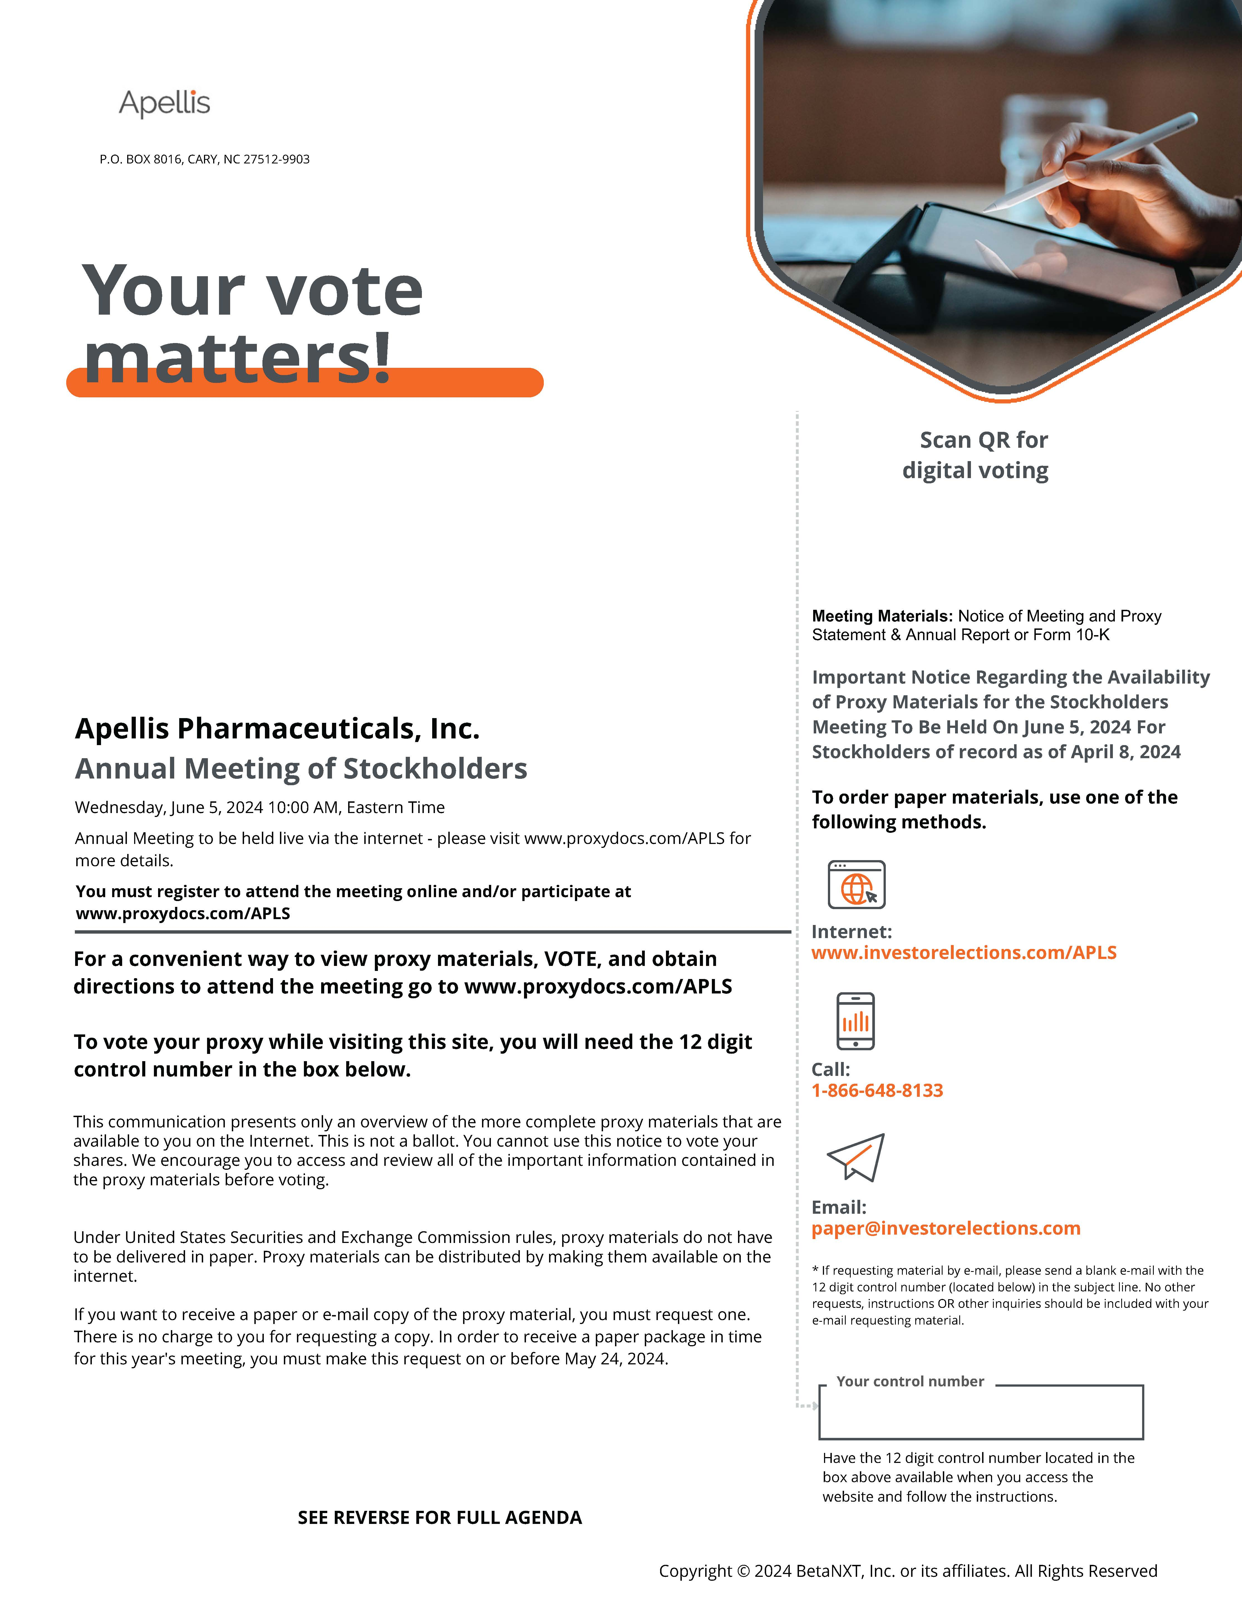 Scan QR for digital voting P.O. BOX 8016, CARY, NC 27512-9903 Your vote matters! Apellis Pharmaceuticals, Inc. Annual Meeting of Stockholders Wednesday, June 5, 2024 10:00 AM, Eastern Time Annual Meeting to be held live via the internet - please visit www.proxydocs.com/APLS for more details. You must register to attend the meeting online and/or participate at www.proxydocs.com/APLS For a convenient way to view proxy materials, VOTE, and obtain directions to attend the meeting go to www.proxydocs.com/APLS To vote your proxy while visiting this site, you will need the 12 digit control number in the box below. This communication presents only an overview of the more complete proxy materials that are available to you on the Internet. This is not a ballot. You cannot use this notice to vote your shares. We encourage you to access and review all of the important information contained in the proxy materials before voting. Under United States Securities and Exchange Commission rules, proxy materials do not have to be delivered in paper. Proxy materials can be distributed by making them available on the internet. If you want to receive a paper or e-mail copy of the proxy material, you must request one. There is no charge to you for requesting a copy. In order to receive a paper package in time for this year's meeting, you must make this request on or before May 24, 2024. Meeting Materials: Notice of Meeting and Proxy Statement & Annual Report or Form 10-K Important Notice Regarding the Availability of Proxy Materials for the Stockholders Meeting To Be Held On June 5, 2024 For Stockholders of record as of April 8, 2024 To order paper materials, use one of the following methods. Internet: www.investorelections.com/APLS Call: 1-866-648-8133 Email: paper@investorelections.com * If requesting material by e-mail, please send a blank e-mail with the 12 digit control number (located below) in the subject line. No other requests, instructions OR other inquiries should be included with your e-mail requesting material. Your control number Have the 12 digit control number located in the box above available when you access the website and follow the instructions. SEE REVERSE FOR FULL AGENDA Copyright © 2024 BetaNXT, Inc. or its affiliates. All Rights Reserved
1

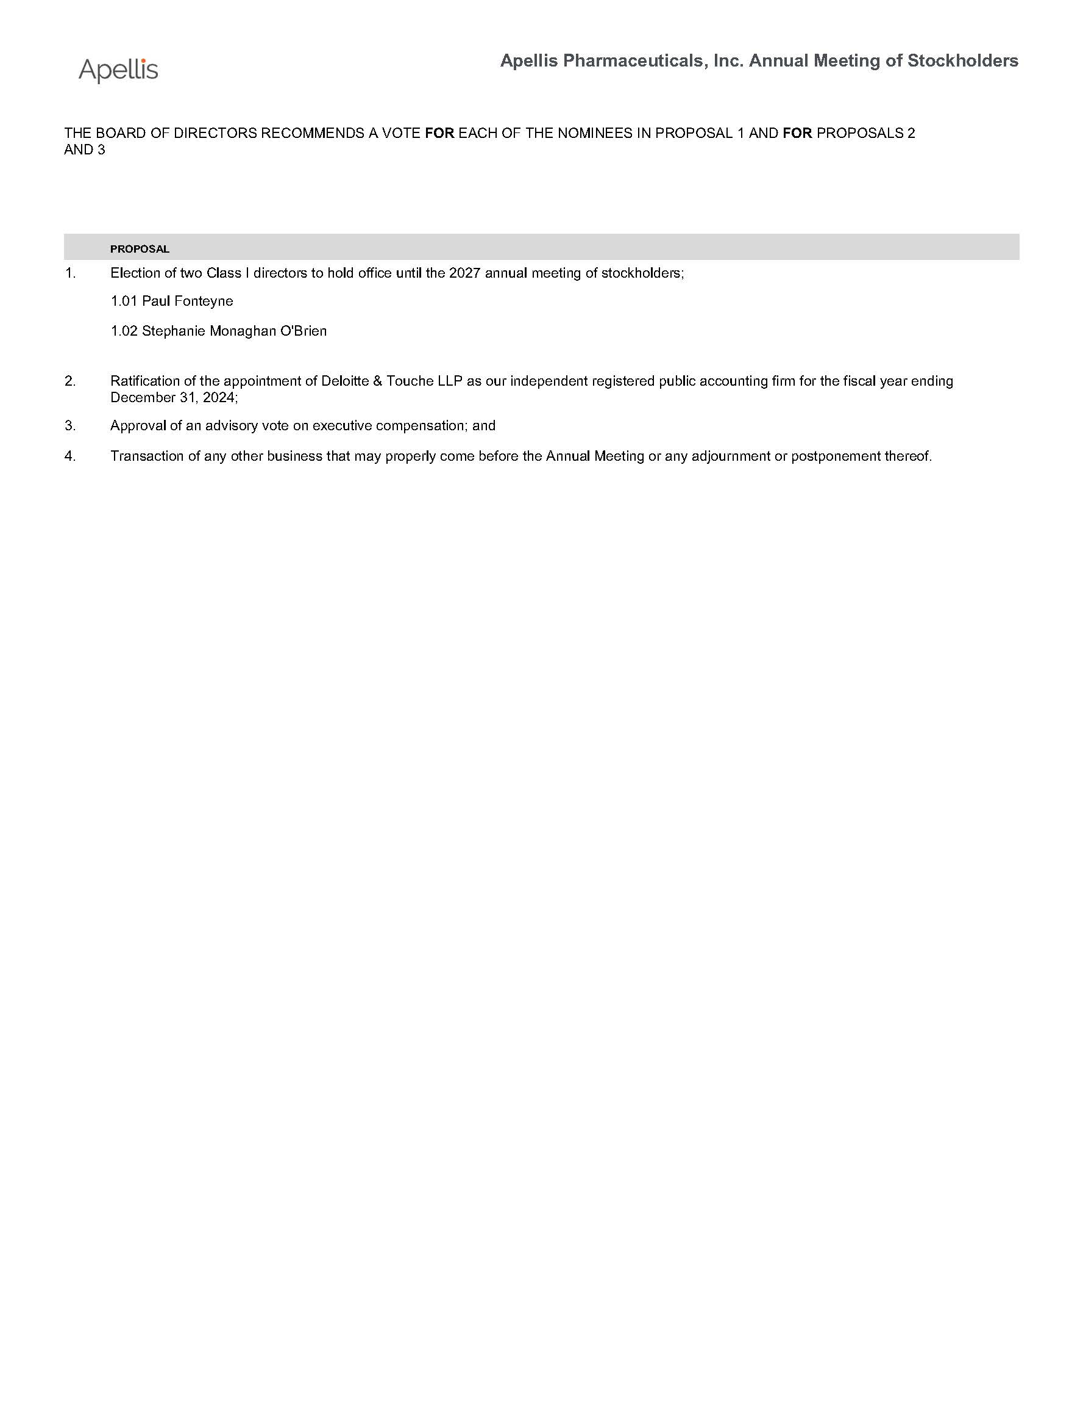 Apellis Pharmaceuticals, Inc. Annual Meeting of Stockholders THE BOARD OF DIRECTORS RECOMMENDS A VOTE FOR EACH OF THE NOMINEES IN PROPOSAL 1 AND FOR PROPOSALS 2 AND 3 PROPOSAL 1. Election of two Class I directors to hold office until the 2027 annual meeting of stockholders; 1.01 Paul Fonteyne 1.02 Stephanie Monaghan O'Brien 2. Ratification of the appointment of Deloitte & Touche LLP as our independent registered public accounting firm for the fiscal year ending December 31, 2024; 3. Approval of an advisory vote on executive compensation; and 4. Transaction of any other business that may properly come before the Annual Meeting or any adjournment or postponement thereof.
2

