UNITED STATES

SECURITIES AND EXCHANGE COMMISSION

WASHINGTON, D.C. 20549

SCHEDULE TO

Tender Offer Statement Pursuant to Section 14(d)(1) or 13(e)(1)

of the Securities Exchange Act of 1934

APELLIS PHARMACEUTICALS, INC.

(Name of Subject Company)

ASPEN PURCHASER SUB, INC.

(Offeror)

A Wholly Owned Subsidiary of

BIOGEN INC.

(Parent of Offeror)

(Names of Filing Persons (identifying status as offeror, issuer or other person))

COMMON STOCK, PAR VALUE $0.0001 PER SHARE

(Title of Class of Securities)

03753U106

(CUSIP Number of Class of Securities)

Wendell Taylor

Biogen Inc.

225 Binney Street

Cambridge, MA 02142

(781) 464-2000

(Name, address and telephone number of person authorized to receive notices and communications on behalf of filing persons)

 | with copies to:
 | Aaron M. Gruber
 | Bethany A. Pfalzgraf
 | Ryan J. Wichtowski
 | Cravath, Swaine & Moore LLP
 | Two Manhattan West
 | 375 Ninth Avenue
 | New York, NY 10001
 | (212) 474-1000
 | CALCULATION OF FILING FEE
Transaction Valuation |  | Amount of Filing Fee
N/A* |  | N/A*

- A filing fee is not required in connection with this filing as it relates solely to preliminary communications made before the commencement of the tender offer.

- Check the box if any part of the fee is offset as provided by Rule 0-11(a)(2) and identify the filing with which the offsetting fee was previously paid. Identify the previous filing by registration statement number, or the Form or Schedule and the date of its filing.

Amount Previously Paid: N/A

Form or Registration No.: N/A

Filing Party: N/A

Date Filed: N/A

- Check the box if the filing relates solely to preliminary communications made before the commencement of a tender offer.

Check the appropriate boxes below to designate any transactions to which the statement relates:

- third-party tender offer subject to Rule 14d-1. ☐ issuer tender offer subject to Rule 13e-4.
☐ going-private transaction subject to Rule 13e-3. ☐ amendment to Schedule 13D under Rule 13d-2.

Check the following box if the filing is a final amendment reporting the results of the tender offer: ☐

If applicable, check the appropriate box(es) below to designate the appropriate rule provision(s) relied upon:

- Rule 13e-4(i) (Cross-Border Issuer Tender Offer)

- Rule 14d-1(d) (Cross-Border Third-Party Tender Offer)

This filing relates solely to pre-commencement communications made before the commencement of a planned tender offer by Aspen Purchaser Sub, Inc., a Delaware corporation (“Purchaser”), a wholly owned subsidiary of Biogen Inc., a Delaware corporation (“Biogen”), for all of the outstanding shares of common stock, par value $0.0001 per share, of Apellis Pharmaceuticals, Inc., a Delaware corporation (“Apellis”, and such shares, the “Apellis Common Stock”), pursuant to the Agreement and Plan of Merger, dated as of March 31, 2026, by and among Biogen, Purchaser and Apellis.

Important Information for Investors and Stockholders and Where to Find It

The tender offer described in this communication has not yet commenced. This communication is for informational purposes only and is neither an offer to purchase nor a solicitation of an offer to sell any Apellis Common Stock or any other securities, nor is it a substitute for the tender offer materials that Biogen or Purchaser will file with the SEC. The terms and conditions of the tender offer will be published in, and the offer to purchase Apellis Common Stock will be made only pursuant to, the offer document and related offer materials prepared by Biogen and Purchaser and filed with the SEC in a tender offer statement on Schedule TO at the time the tender offer is commenced.

THE TENDER OFFER MATERIALS (INCLUDING AN OFFER TO PURCHASE, A RELATED LETTER OF TRANSMITTAL AND CERTAIN OTHER TENDER OFFER DOCUMENTS) AND THE SOLICITATION/RECOMMENDATION STATEMENT ON SCHEDULE 14D-9, AS THEY MAY BE AMENDED FROM TIME TO TIME, WILL CONTAIN IMPORTANT INFORMATION. INVESTORS AND APELLIS SECURITYHOLDERS ARE URGED TO READ THESE DOCUMENTS CAREFULLY WHEN THEY BECOME AVAILABLE BECAUSE THEY WILL CONTAIN IMPORTANT INFORMATION THAT SUCH PERSONS SHOULD CONSIDER BEFORE MAKING ANY DECISION REGARDING TENDERING THEIR COMMON STOCK.

The tender offer materials, including the offer to purchase and the related letter of transmittal and certain other tender offer documents, and the solicitation/recommendation statement (when they become available) and other documents filed with the SEC by Biogen or Apellis, may be obtained free of charge at the SEC’s website at www.sec.gov or at Biogen’s website at https://www.biogen.com/ or at Apellis’ website at https://investors.apellis.com/news-releases. In addition, Biogen’s tender offer statement and other documents it will file with the SEC will be available at https://investors.biogen.com/.

Cautionary Note Regarding Forward-Looking Statements

This communication contains forward-looking statements, relating to, among others, statements regarding the expected timetable for completing the proposed transaction, benefits of the proposed transaction, financing of the proposed transaction, costs and other anticipated financial impacts of the proposed transaction. These forward-looking statements may be accompanied by such words as “aim,” “anticipate,” “assume,” “believe,” “contemplate,” “continue,” “could,” “estimate,” “expect,” “forecast,” “goal,” “guidance,” “hope,” “intend,” “may,” “objective,” “outlook,” “plan,” “possible,” “potential,” “predict,” “project,” “prospect,” “should,” “target,” “will,” “would” or the negative of these words or other words and terms of similar meaning. Drug development and commercialization involve a high degree of risk, and only a small number of research and development programs result in commercialization of a product. Results in early-stage clinical trials may not be indicative of full results or results from later stage or larger scale clinical trials and do not ensure regulatory approval. You should not place undue reliance on these statements. Given their forward-looking nature, these statements involve substantial risks and uncertainties that may be based on inaccurate assumptions and could cause actual results to differ materially from those reflected in such statements.

These forward-looking statements are based on management’s current beliefs and assumptions and on information currently available to management. Given their nature, we cannot assure that any outcome expressed in these forward-looking statements will be realized in whole or in part. We caution that these statements are subject to risks and uncertainties, many of which are outside of our control and could cause future events or results to differ materially from those stated or implied in this document, including, among others, the delay or failure of the tender offer conditions to be satisfied (or waived), including insufficient shares of Apellis common stock being tendered in the tender offer; the timing to consummate the proposed transaction; the risk that the conditions to closing of the proposed transaction may not be satisfied or that the closing of the proposed transaction otherwise does not occur; the risk that a regulatory approval that may be required to consummate the proposed transaction is not obtained or is obtained subject to conditions that are not anticipated or conditions that Biogen is not obligated to accept; the diversion of management time on transaction-related issues; expectations regarding regulatory approval of the transaction; results of litigation, settlements and investigations; actions by third parties, including governmental agencies; global economic conditions; adverse industry conditions; potential business uncertainty, including changes to existing business relationships during the pendency of the proposed transaction that could affect financial performance; legal proceedings; governmental regulation; the ability to retain management and other personnel; that all or any of the contingent consideration will become payable on the terms described herein; the accuracy of Biogen’s estimates of the size and characteristics of the markets that may be addressed by its product candidates; Biogen’s ability to increase its manufacturing capabilities for its products and product candidates; and other economic, business, or competitive factors. and any other risks and uncertainties that are described in other reports we have filed with the U.S. Securities and Exchange Commission, which are available on the SEC’s website at www.sec.gov.

These statements speak only as of the date of this press release and are based on information and estimates available to us at this time. Should known or unknown risks or uncertainties materialize or should underlying assumptions prove inaccurate, actual results could vary materially from past results and those anticipated, estimated or projected. Investors are cautioned not to put undue reliance on forward-looking statements. A further list and description of risks, uncertainties and other matters can be found in our Annual Report on Form 10-K for the fiscal year ended December 31, 2025, and in our subsequent reports on Form 10-Q. Except as required by law, we do not undertake any obligation to publicly update any forward-looking statements whether as a result of any new information, future events, changed circumstances or otherwise.

 |  |  | EXHIBIT INDEX
Exhibit
No. |  |  | Description
99.1 |  | Social media posts made on March 31, 2026

Exhibit 99.1

Exhibit 99.1

LinkedIn:

The following communication was posted by Biogen Inc. (the “Company”) on LinkedIn on March 31, 2026.

Frame 1:
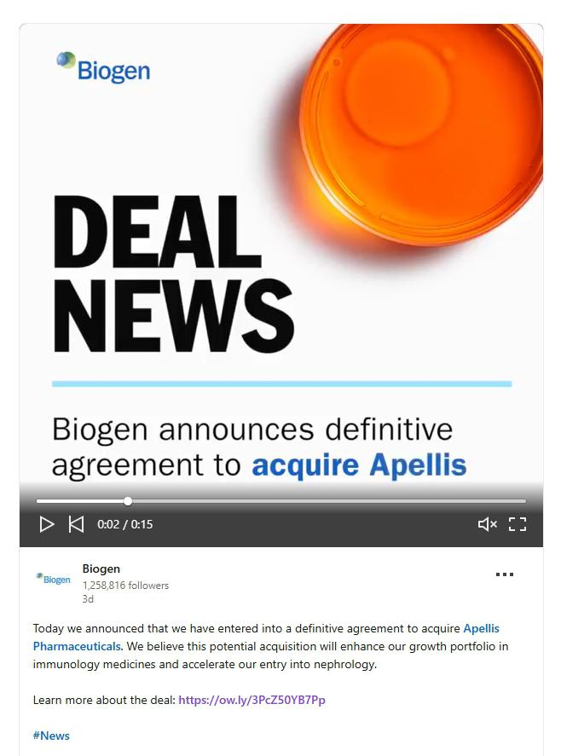

Biogen DEAL NEWS Biogen announces definitive agreement to acquire Apellis Today we announced that we have entered into a definitive agreement to acquire Apellis Pharmaceuticals. We believe this potential acquisition will enhance our growth portfolio in immunology medicines and accelerate our entry into nephrology. Learn more about the deal: https://ow.ly/3PcZ5OYB7Pp #News

Frame 2:
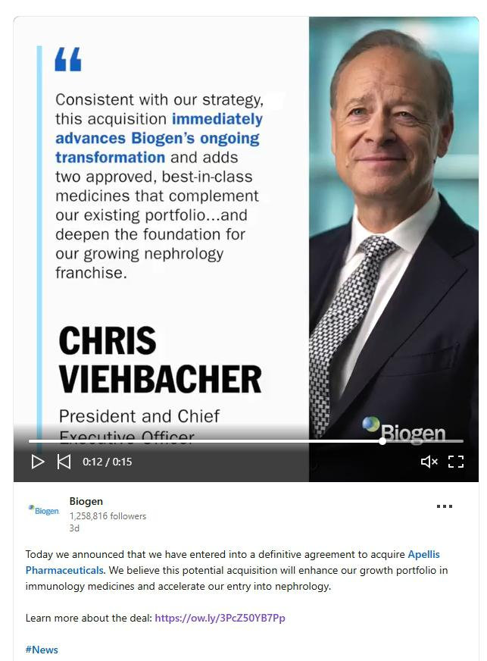

Consistent with our strategy, this acquisition immediately advances Biogen's ongoing transformation and adds two approved, best-in-class medicines that complement our existing portfolio...and deepen the foundation for our growing nephrology franchise.CHRIS VIEHBACHERPresident and Chief Today we announced that we have entered into a definitive agreement to acquire Apellis Pharmaceuticals. We believe this potential acquisition will enhance our growth portfolio in immunology medicines and accelerate our entry into nephrology. Learn more about the deal: https://ow.ly/3PcZ5OYB7Pp #News

The following communication was posted by the Company on X (formerly Twitter) on March 31, 2026.

Frame 1:
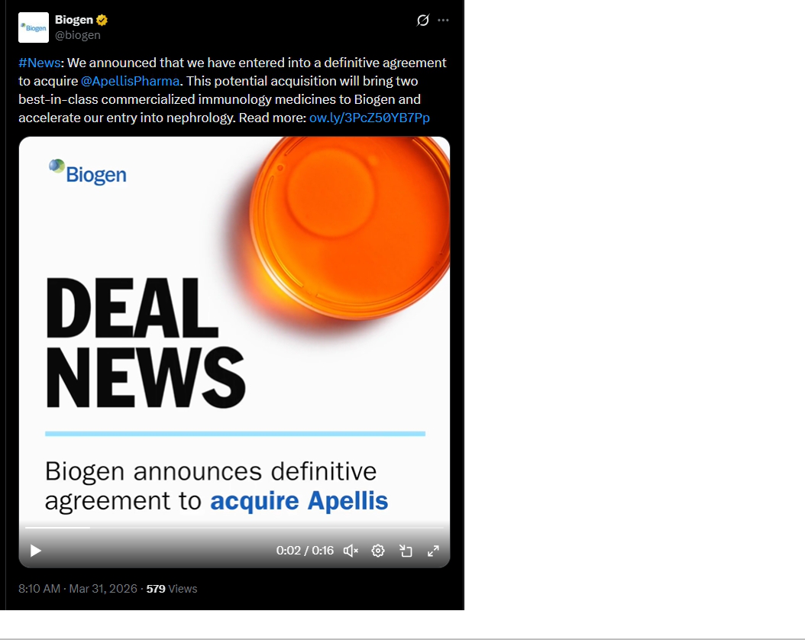

Frame 2:
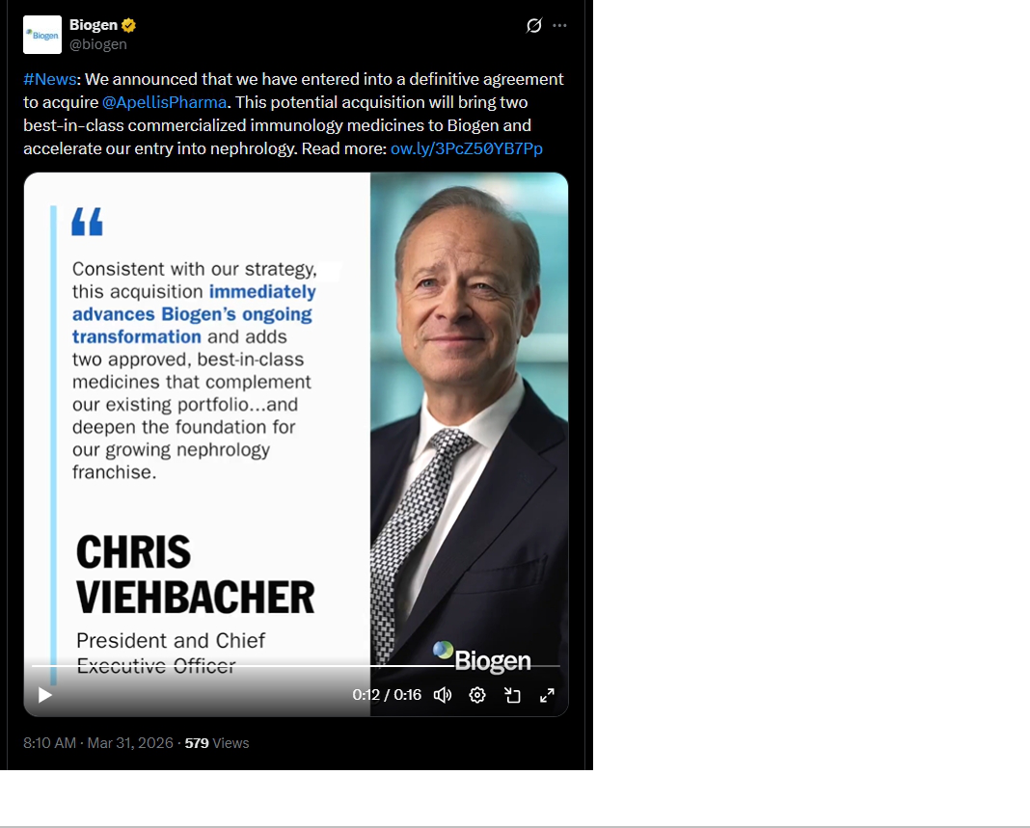

Important Information for Investors and Stockholders and Where to Find It

The tender offer described in this communication has not yet commenced. This communication is for informational purposes only and is neither an offer to purchase nor a solicitation of an offer to sell any Apellis Common Stock or any other securities, nor is it a substitute for the tender offer materials that Biogen or Purchaser will file with the SEC. The terms and conditions of the tender offer will be published in, and the offer to purchase Apellis Common Stock will be made only pursuant to, the offer document and related offer materials prepared by Biogen and Purchaser and filed with the SEC in a tender offer statement on Schedule TO at the time the tender offer is commenced.

THE TENDER OFFER MATERIALS (INCLUDING AN OFFER TO PURCHASE, A RELATED LETTER OF TRANSMITTAL AND CERTAIN OTHER TENDER OFFER DOCUMENTS) AND THE SOLICITATION/RECOMMENDATION STATEMENT ON SCHEDULE 14D-9, AS THEY MAY BE AMENDED FROM TIME TO TIME, WILL CONTAIN IMPORTANT INFORMATION. INVESTORS AND APELLIS SECURITYHOLDERS ARE URGED TO READ THESE DOCUMENTS CAREFULLY WHEN THEY BECOME AVAILABLE BECAUSE THEY WILL CONTAIN IMPORTANT INFORMATION THAT SUCH PERSONS SHOULD CONSIDER BEFORE MAKING ANY DECISION REGARDING TENDERING THEIR COMMON STOCK.

The tender offer materials, including the offer to purchase and the related letter of transmittal and certain other tender offer documents, and the solicitation/recommendation statement (when they become available) and other documents filed with the SEC by Biogen or Apellis, may be obtained free of charge at the SEC’s website at www.sec.gov or at Biogen’s website at https://www.biogen.com/ or at Apellis’ website at https://investors.apellis.com/news-releases. In addition, Biogen’s tender offer statement and other documents it will file with the SEC will be available at https://investors.biogen.com/.

Cautionary Note Regarding Forward-Looking Statements

This communication contains forward-looking statements, relating to, among others, statements regarding the expected timetable for completing the proposed transaction, benefits of the proposed transaction, financing of the proposed transaction, costs and other anticipated financial impacts of the proposed transaction. These forward-looking statements may be accompanied by such words as “aim,” “anticipate,” “assume,” “believe,” “contemplate,” “continue,” “could,” “estimate,” “expect,” “forecast,” “goal,” “guidance,” “hope,” “intend,” “may,” “objective,” “outlook,” “plan,” “possible,” “potential,” “predict,” “project,” “prospect,” “should,” “target,” “will,” “would” or the negative of these words or other words and terms of similar meaning. Drug development and commercialization involve a high degree of risk, and only a small number of research and development programs result in commercialization of a product. Results in early-stage clinical trials may not be indicative of full results or results from later stage or larger scale clinical trials and do not ensure regulatory approval. You should not place undue reliance on these statements. Given their forward-looking nature, these statements involve substantial risks and uncertainties that may be based on inaccurate assumptions and could cause actual results to differ materially from those reflected in such statements.

These forward-looking statements are based on management’s current beliefs and assumptions and on information currently available to management. Given their nature, we cannot assure that any outcome expressed in these forward-looking statements will be realized in whole or in part. We caution that these statements are subject to risks and uncertainties, many of which are outside of our control and could cause future events or results to differ materially from those stated or implied in this document, including, among others, the delay or failure of the tender offer conditions to be satisfied (or waived), including insufficient shares of Apellis common stock being tendered in the tender offer; the timing to consummate the proposed transaction; the risk that the conditions to closing of the proposed transaction may not be satisfied or that the closing of the proposed transaction otherwise does not occur; the risk that a regulatory approval that may be required to consummate the proposed transaction is not obtained or is obtained subject to conditions that are not anticipated or conditions that Biogen is not obligated to accept; the diversion of management time on transaction-related issues; expectations regarding regulatory approval of the transaction; results of litigation, settlements and investigations; actions by third parties, including governmental agencies; global economic conditions; adverse industry conditions; potential business uncertainty, including changes to existing business relationships during the pendency of the proposed transaction that could affect financial performance; legal proceedings; governmental regulation; the ability to retain management and other personnel; that all or any of the contingent consideration will become payable on the terms described herein; the accuracy of Biogen’s estimates of the size and characteristics of the markets that may be addressed by its product candidates; Biogen’s ability to increase its manufacturing capabilities for its products and product candidates; and other economic, business, or competitive factors. and any other risks and uncertainties that are described in other reports we have filed with the U.S. Securities and Exchange Commission, which are available on the SEC’s website at www.sec.gov.

These statements speak only as of the date of this press release and are based on information and estimates available to us at this time. Should known or unknown risks or uncertainties materialize or should underlying assumptions prove inaccurate, actual results could vary materially from past results and those anticipated, estimated or projected. Investors are cautioned not to put undue reliance on forward-looking statements. A further list and description of risks, uncertainties and other matters can be found in our Annual Report on Form 10-K for the fiscal year ended December 31, 2025, and in our subsequent reports on Form 10-Q. Except as required by law, we do not undertake any obligation to publicly update any forward-looking statements whether as a result of any new information, future events, changed circumstances or otherwise.

